Name: **ZOHAIB HASSAN SOOMRO**

RollNo#: **19SW42**

Subject: **DBS**



1. Write a query that displays employees whose job is same as that of employee 7369 and whose salary is greater than that of employee 7876.

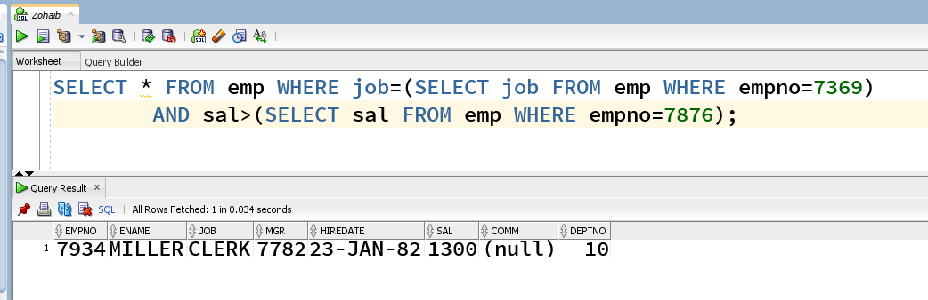

1. Write a query that displays all the departments that have a minimum salary greater than that of department 30.

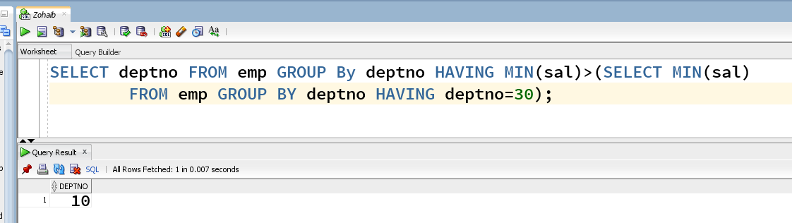

1. Find the job with the lowest average salary.

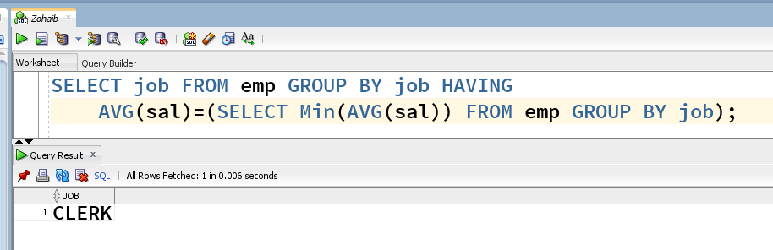

1. Write a SQL statement that displays all the employees whose salary is less than any CLERK and who are not CLERK.

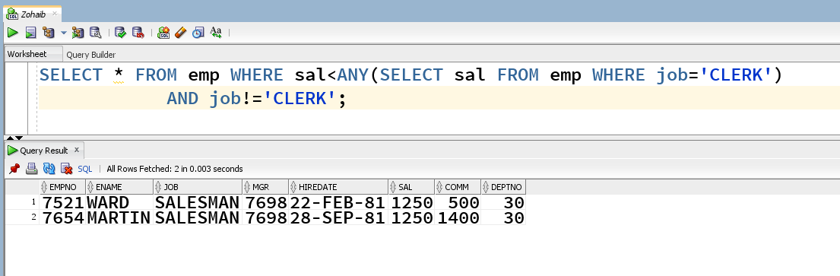

1. Find the employees who earn same salary as the minimum salary for departments.

